Ref. COMM(26)02271
02/10/2026

Press Release
Copa and Cogeca presidencies renewed at a critical juncture for European agriculture
On Thursday and Friday in Brussels, lead representatives of Europe’s farming and agri-cooperative sectors met in a turbulent agricultural climate, following a summer of record-breaking events and just weeks before crucial decisions on the future of EU agricultural policy. With major challenges looming, stability and continuity prevailed, as both the Copa and Cogeca presidencies were renewed to steer the organisations through the difficult months ahead.
European farmers confirmed Massimiliano Giansanti, from Italian Confagricoltura, as President, to lead COPA for the next two years. As an agricultural entrepreneur, Mr. Giansanti manages farms with his family mainly producing Parmigiano Reggiano, cereal crops, kiwis, dairy products as well as solar energy.
Following his reelection Massimiliano Giansanti declared: “I am honoured by the trust that has been placed in me once again today, at a time we have all described as critical and alarming. We are all fully aware that the decisions to be taken at EU level in the coming weeks will shape the lives of millions of farmers for years to come.
After yet another challenging summer, Europe’s farmers are now looking for clear action, not more words. We will fight to defend a strong Common Agricultural Policy, secure an increased budget that keeps pace with inflation, advance the simplification agenda and ensure a coherent EU trade policy. The time to act is now!”
Massimiliano Giansanti will continue his Presidency together with his team of six reelected Vice-Presidents: Nikolaus Berlakovich (LKÖ, Austria), Søren Søndergaard (DAFC, Denmark), Franck Sander (FNSEA, France), Pedro Barato (ASAJA, Spain), Jan Doležal (AKCR, Czech Republic) and Francie Gorman (IFA, Ireland).
Lennart Nilsson arable farmer from the Swedish organisation LRF was confirmed as leader of COGECA. His mandate will last for all 2027. Since 1990, Lennart has farmed with his family Charolais cattle on arable land and pasture.
Lennart Nilsson declared on his side: “For European agricultural cooperatives, the battle ahead is the same as for farmers across Europe. Supporting investment in our agri-cooperatives and preserving the stability of our Single Market must be central to the ongoing CAP and MFF negotiations.
In today’s geopolitical and climate environment, amid rapidly rising costs and inflation, the purpose of the CAP and the need for a strong budget have never been more relevant or more essential! We must defend the CAP because, in doing so, we are also defending the very foundations of the European Union. And we intend to make sure that all our European leaders hear this message loud and clear.”
Lennart Nilsson will continue to be supported by the following six Vice-Presidents: Agnieszka Maliszewska (Federacja Branżowych Związków Producentów Rolnych, Poland), Leonardo Pofferi (Alleanza delle Cooperative Italiane, Italy), Florentin Bercu (Alliance for Agriculture and Cooperation, Romania), Mickaël Marcerou (La Coopération Agricole, France), Christian Høegh-Andersen (Landbrug & Fødevarer, Denmark) and Idalino Leão (Confederacão Nacional das Cooperativas Agrícolas e do Crédito Agrícola de Portugal, Portugal).
-END-
Translations will be available in DE, ES, FR, IT, PL and RO on the Copa-Cogeca website soon.
About us - Copa and Cogeca are the united voice of farmers and agri-cooperatives in the EU. Together, we ensure that EU agriculture is sustainable, innovative and competitive, while guaranteeing food security for 500 million people throughout Europe. >>> More information www.copa-cogeca.eu

Note to editors: All elected representatives’ CVs are available on Copa-Cogeca’s website + Photos to find below.
For further information, please contact
Patrick Pagani  Deputy Secretary General  patrick.pagani@copa-cogeca.eu | Jean-Baptiste Boucher  Communication Director  jean-baptiste.boucher@copa-cogeca.eu  +32 474 84 08 36

Press Release Mailing List
Unsubscribe
Subscribe

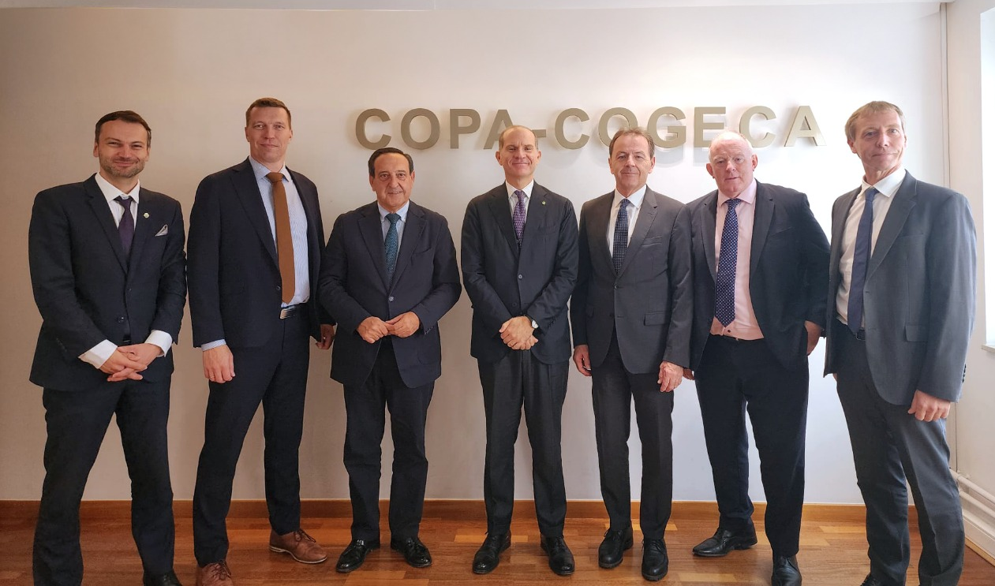
COPA Presidency
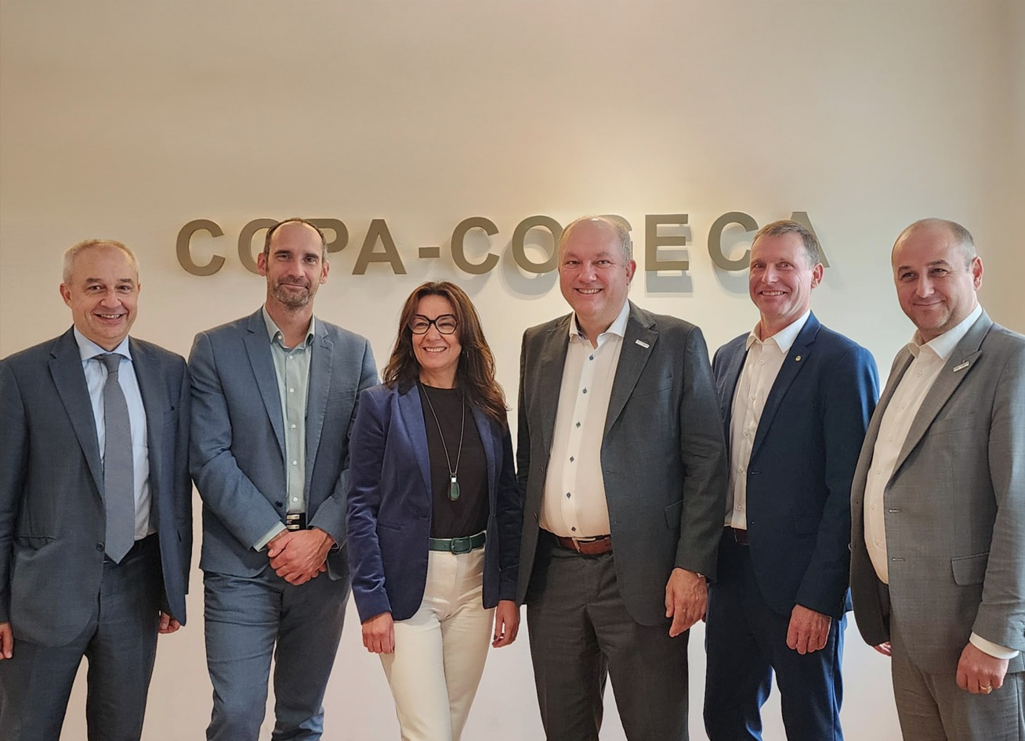
COGECA Presidency (Missing on the picture: Idalino Leão)

