Ref. COMM(23)02351
11/04/2023

Press Release
Honey fraud - Copa and Cogeca launch #HoneYstLabellingNow campaign
Today, Copa and Cogeca's Honey Working Party held an online press conference to address the shocking revelations of studies conducted by the European Commission services on the adulteration of every second honey tested on the European market. The solutions to tackle this massive fraud are known and must be implemented in the upcoming revision of the EU Honey Directive. It is in this context that Copa and Cogeca have launched a call for mobilisation to all EU beekeepers on social media under the hashtag #HoneYstlabellingNow.
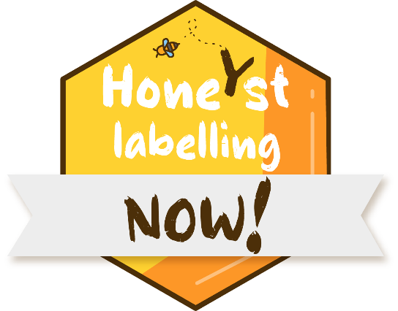

European professional beekeepers are on their knees. Once again, climate change has affected production in 2022 coupled with soaring prices. Several important European markets such as Hungary, Spain and Italy have ceased to function. The increase in beekeepers' selling prices is not passed on to the market, which prefers cheaper imported honey, today mainly from China, but in the future why not from Vietnam and India. Thus, the EU could lose a third of its hives in the coming years meaning further imports.
Against this backdrop, the publication by the European Commission services of a study proving massive fraud on these imported honeys is the straw that has broken the camel's back! Of the 320 samples received from the competent authorities of the participating countries, 147 (46%) were suspected of not complying with the provisions of the European directive on honey. Official methods currently used are not suitable for detecting all present frauds. A complete panel of frequently updated and validated techniques is necessary to highlight a maximum of frauds. Considering also that the addition of sugar syrup does not cover other types of adulteration, such as immature honeys, false designations or the addition of colouring agents, frauds could be even more massive.
“The situation is extremely worrying, and we need a quick response from EU decision makers. All European beekeepers agree on the problem but also on the major European solutions. In light of the ongoing revision of the honey directive, European beekeepers and their cooperatives are calling for transparent labelling of the country of origin, with the percentage in descending order, enhancing better traceability, and a modern harmonised European framework for laboratory testing of a honey” said Stanislav Jas, Chair of the Copa and Cogeca Honey Working Party.
He added, “The European Commission must hear this message, this is why we call on all European beekeepers who support these principles to gather around the hashtag #HoneYstlabellingnow to explain their situations via social networks, to give examples of counterfeits and to call, along with us, for a transparent labelling of the country of origin on all imported honey.”
-END-
Translations will be available in DE, ES, FR, IT, PL and RO on the Copa-Cogeca website soon.
About us - Copa and Cogeca are the united voice of farmers and agri-cooperatives in the EU. Together, we ensure that EU agriculture is sustainable, innovative and competitive, while guaranteeing food security for 500 million people throughout Europe. >>> More information www.copa-cogeca.eu

For further information, please contact
Federico Facchin  Senior Policy Advisor  federico.facchin@copa-cogeca.eu | Jean-Baptiste Boucher  Communication Director  +32 474 840 836  jean-baptiste.boucher@copa-cogeca.eu

