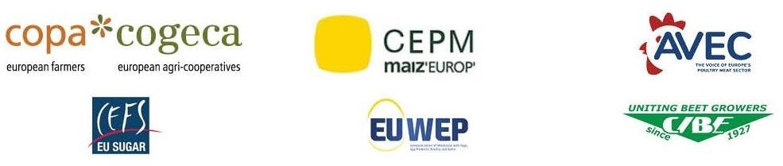

COMM(24)01308

23/04/2024

Joint Statement
Formal approval of the Ukraine ATMs – EU institutions will have to do better for the revision of the association agreement!
Today, the European Parliament formally approved by 428 in favour (with 131 against and 44 abstentions) the compromise on the renewal of Ukraine trade measures that was reached by institutions on 8th April. While this agreement represents an improvement compared to previous ATMs, it remains challenging for EU producers and manufactuers who will also scrutinise its proper implementation. All attention must now be focused on the revision of the Association Agreement between Ukraine and the EU that will be governing our trade relationship with Ukraine after 6th June 2025. EU producers and manufacturers will have to be included in this discussion and their demands answered in order to ensure a balanced outcome.
Although the compromise extends the reference period, incorporating the latter half of 2021, and includes some additional products like oats and groats, it falls short of addressing EU producers and manufacturers concerns. The imported volumes will remain significant and will continue to affect the markets. Furthermore, no restrictions are planned for the hugely impacting cereals such as common wheat and barley. As such, the spotlight now turns to the renegotiation of the Association Agreement to ensure better protection for European producers and manufacturers and uphold standards against long-term effects.
Solidarity with Ukrainian farmers remains essential and EU farmers and manufacturers remain ready to do their part. One cannot forget, that with this ATM, the volumes exported to Europe remain substantial and will not be sustainable in the long-term especially with the standards of production and crop cultivation in Ukraine remaining lower than in the EU. For the survival of the EU’s sensitive sectors, it will be essential for European institutions to ensure that the revised Association Agreement will provide the necessary guarantees to preserve EU producers and manufacturers economic viability.

On behalf of the following associations:
AVEC – Association of Poultry Processors and Poultry Trade in the EU countries
CEFS – European Association of Sugar Manufacturers
CEPM – European Confederation of Maize Production
CIBE – International Confederation of European Beet Growers
COPA-COGECA - The united voice of farmers and their cooperatives in the European Union
EUWEP - European Union of Wholesale with Eggs, Egg Products, Poultry and Game
-END-
Translations will be available in DE, ES, FR, IT, PL and RO on the Copa-Cogeca website soon.

For further information, please contact

Birthe Steenberg - Secretary General AVEC׀ELPHA׀EPB +32 492 10 75 71 bs@avec- poultry.eu
Catherine Jaworowska- Communications & Social Affairs Officer CEFS +32 2 774 51 07
catherine.jaworowska@cefs.org
Arthur Boy - Policy Advisor for economic affairs CEPM arthur.boy@agpm.com +33 6 79 05 78 31
Elisabeth Lacoste – Director CIBE +32 2 50 46 091 elisabeth.lacoste@cibe-europe.eu
Bruno Menne - Director of Commodities COPA-COGECA +32 478 18 99 09 bruno.menne@copa-cogeca.eu
Clara Hagen - Secretary General EUWEP +31 30 637 8844 Clara.Hagen@euwep.org

